**VLSI Overview:**

* **Definition:** VLSI stands for Very Large Scale Integration.
* **Integration:** Refers to the integration of millions and billions of transistors on a single chip.
* **Transistor Technology:**
  + Early technologies: Bipolar Junction Transistors (BJT), followed by Field-Effect Transistors (FET).
  + Current standard: CMOS (Complementary Metal Oxide Semiconductor) transistors.
* **Advancement:** The technology has progressed rapidly, from integrating thousands of transistors on a chip decades ago to now millions and billions.

**Evolution of Integration:**

* **SSI (Small Scale Integration):** Less than 100 components on a single chip.
* **MSI (Medium Scale Integration):** Integration of around 500 components.
* **LSI (Large Scale Integration):** Integration of up to 300,000 components, made possible by Computer-Aided Design (CAD) tools.
* **VLSI:** Integration of millions and billions of components. Sometimes ULSI (Ultra Large Scale Integration) is mentioned, but it is generally considered part of VLSI.

**Technological Advancements:**

* **Example of Hard Disks:**
  + The first hard disk by IBM had a capacity of 10 MB and was very bulky.
  + Modern hard disks are compact (2.5 inches in width) with capacities in terabytes, demonstrating significant advancements in VLSI.

**VLSI Design Flow:**

* **Process:** Involves designing, simulation, testing, and verification.
* **Steps:**
  + **User Specifications:** Define the system and constraints like chip area and power usage.
  + **Architecture Design:** Different architectures are studied.
  + **Logic Design:** Determine how to connect inputs and generate outputs.
  + **HDL Coding:** Hardware Descriptive Language coding, focusing on Verilog.
  + **RTL Verification:** Register Transfer Level verification ensures the correctness of the design.
  + **Fabrication:** If the design meets specifications, it is sent for fabrication; otherwise, it is optimized and retested.

**Moore’s Law:**

* **Definition:** Gordon Moore in 1965 predicted that the number of transistors on a chip would double every 14-18 months.
* **Implication:** This predicted exponential growth in VLSI, with decreasing chip sizes and increasing circuit speeds.
* **Historical Data:** Shows a straight line on a logarithmic scale between years (x-axis) and the number of transistors on a chip (y-axis), confirming Moore’s Law.

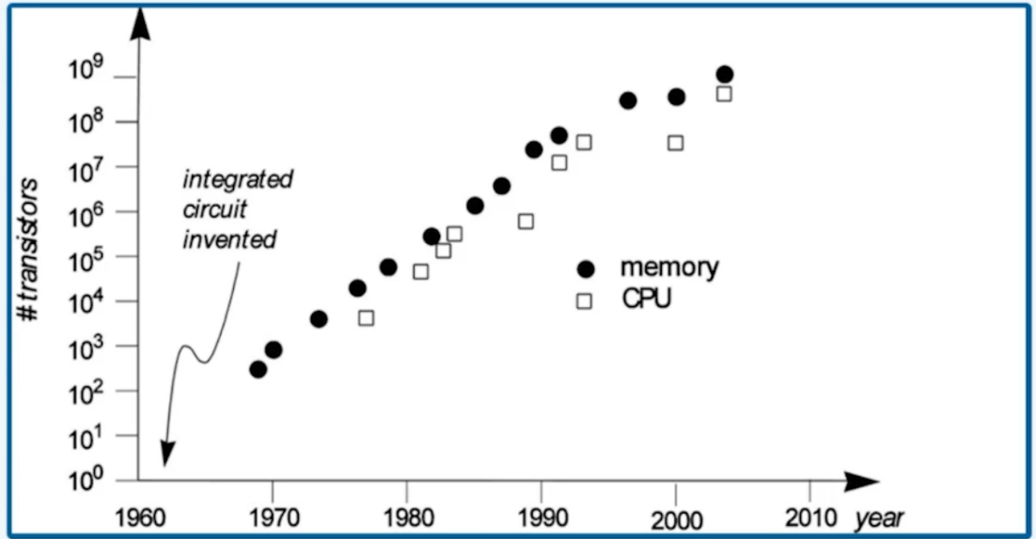

**Evolution of Microprocessors:**

* **1971:** Introduction of the 4-bit microprocessor MP4004.
* **1974:** Launch of the 8-bit microprocessor 8008.
* **1978:** 16-bit microprocessor 8086, significantly expanding computing capabilities.
* **1986:** Introduction of 32-bit microprocessors like 80286 and the revolutionary Pentium processor in 1993, which brought computers into homes.
* **2010:** Intel's 64-bit microprocessors in the i3, i5, and i7 series, representing the modern, high-performing microprocessors.